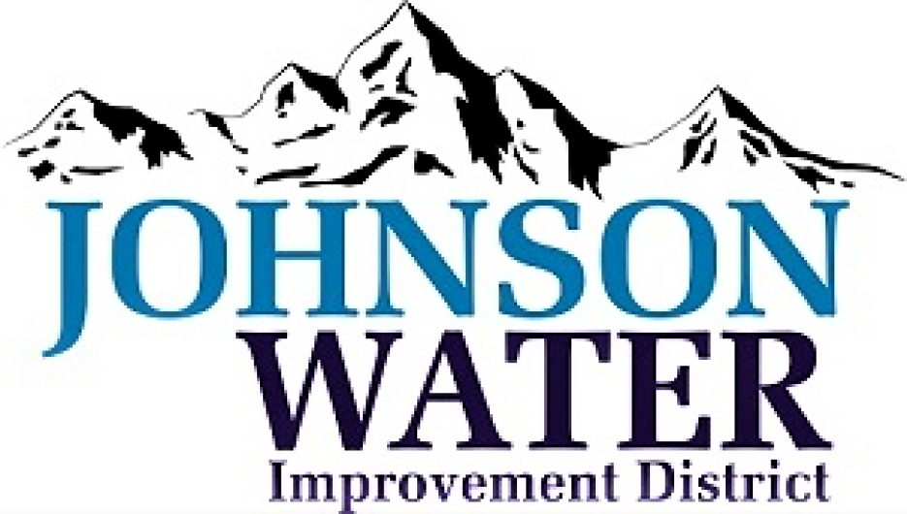

**Job Description – Water System Manager**

**Job Description:** Water SystemManager

**Job Title:** Water SystemManager

**Department:** Administration

**Employment Status:** Regular, Full-time

**Supervisor’s Name/Title:** Board of Directors

**Date Updated:** 6/12/23

**Position Summary:**

The Manager is responsible for delivering safe and reliable drinking water to customers. Ensures the District follows local, state, and federal water regulations and compliance requirements. The Manager also ensures the operation and maintenance of the water system, develops policies and procedures, manages the budget, fosters positive relationships with customers and stakeholders, collaborates with agencies on water quality issues, and supervises staff. Field duties may be required when necessary.

**Major Responsibilities and Time Allocation:**

1. Management:
   * Oversee the operation and maintenance of the water system, including supply, treatment, distribution, new development, and customer service.
   * Develop and implement maintenance and repair programs to ensure the water distribution system operates efficiently and effectively.
   * Develop and recommend policies and procedures for the water system in compliance with state and federal regulations.
   * Implement policy, goals, and objectives as directed by the JWID board and identify resource needs to fulfil them.
   * Manage the water system's budget and financial resources, including forecasting, planning, and tracking expenditures and revenue.
   * Foster positive relationships with customers, stakeholders, and the community.
   * Maintain accurate and up-to-date records and prepare reports as needed.
   * Collaborate with local, state, and federal agencies on water quality, water conservation, and related issues.
   * Collaborate closely with the Board of Directors to ensure their continuous awareness of the water system's requirements and operational necessities.
   * Prepare and present status and operational reports for the JWID board.
   * Plan, organize, supervise, train, and evaluate the performance of assigned staff. Establish performance requirements, personal development targets, and monitor performance regularly. Provide coaching for performance improvement and development. Recommend compensation and take disciplinary action, if necessary, in accordance with the District's rules, policies, and labor contract provisions. Ensure the adoption of best-of-class work practices among assigned staff.
   * Ensure staff observe and comply with all District and mandated safety rules, regulations, and protocols.
   * Conduct field inspections, read and interpret specifications on blueprints and schematic drawings, and make recommendations to resolve construction, maintenance, and design problems.
   * Ensure the delivery of safe, clean, and reliable drinking water to the community.
   * Identify projects that support growth, enhance system improvements, and address maintenance requirements. Identify and engage with funding sources to secure funding for these projects.
   * Safeguard the water distribution systems is in compliance with local, state and federal regulations
   * Administer the Blue Stake Process
   * Overseeing Chlorine Testing, ensuring tests are performed in accordance with State standards
2. Manage Meter Reading, Checking and Repair
   * Checking and repairing/replacing defective meters
   * Ensuring accurate meter readings for billing purposes
3. Supplying and Managing the Delivery of Fracturing Water
   * Supplying and managing the delivery of fracturing water
4. Ensure timely Repair & Replacement Broken Water Lines
   * Addressing and resolving issues related to broken water lines
5. Oversee securing all required Easements and Rights of Way, land rights and due diligence work.
6. Able to react to change productive and handle other essential tasks as assigned.

**Supervision:**

Functions under the direction of the board of directors

**Supervisory Responsibility:**

This position has supervisory responsibility for Office Managers, Operators, and Laborers.

**Access to Confidential Information:**

Manager/Operator has access to confidential information, including salary/wage information, disciplinary actions, and performance review data.

**Access to or Handling of Company Funds:**

Incumbent handles company funds, including credit cards and access to vendor accounts.

**Language Proficiency:**

Fluency in English is important for effective communication, including answering phones, dealing with customers, and communicating with contractors.

**Required Qualifications:**

* High School Diploma/GED
* Experience in Water Resources Management, or a related field.
* A certification as a Water Manager, Water Distribution Operator, or equivalent
* At least 5 years of experience in water distribution and maintenance operations, including experience in managing teams of staff.
* Knowledge of local, state, and federal regulations related to water distribution and maintenance.
* Experience in budget management and cost control.
* Participate in a 24/7 on-call rotational schedule

**Required Technical Skills:**

* Proficiency in Microsoft Office
* Experience with mapping software (Field Maps)
* Knowledge of SCADA programs
* Familiarity with meter reading software (Neptune)
* Ability to read survey and field maps

**Other Special Training and Abilities:**

* Certified Water Operator through the State of Utah
* Understand Water Rights
* Ability to become Certified Backflow Administrator

**Factors Important to Successful Performance:**

* Problem Solving
* Analytical Ability
* Communication Skills
* Interpersonal Skills
* Dexterity
* Working Conditions:

**Physical Demands:**

* Standing: 50% of time
* Walking: 25% of time
* Sitting: 25% of time
* Lifting: Up to 85 lbs.
* Carrying: Up to 75 lbs.
* Climbing and balancing: Required (rugged terrain, in and out of backhoes/graders)
* Stooping, kneeling, crouching, and crawling: Required
* Reaching and handling: Required
* Speaking and hearing: Required
* Seeing: Required
* Depth perception: Required
* Color vision: Required