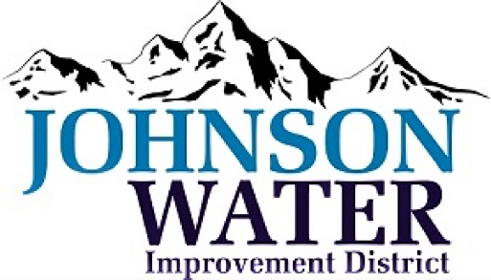

**Job Description – Lead Field Operator**

Job Title: Lead Field Operator

Employment Status: Regular, Full-time

Department: Water Distribution

Supervisor’s Name/Title: Managers

Reg. hours worked: 40/wk with 24/7 on call rotation

Exempt: ☒ Non-exempt: ☐

Last Updated: 6/28/23

**Overall Purpose and Objective:**

The Operator is responsible for ensuring safe and reliable operation of our water system. They play a crucial role in managing Frac water, maintaining equipment, ensuring cross connection control and backflow prevention, and handling various administrative tasks as well as a strong commitment to providing excellent customer service to our customers.

**Major Responsibilities and Time Allocation:**

1. Operating & Maintaining Water Distribution Systems:

* Balancing tanks and reconciling water quantities (barrels, acre feet, gallons)
* Communicating and collaborating with treatment plants, the conservation district, public work agencies, engineering firms and other stakeholder.
* Coordinating and managing the activities to ensure an efficient and effective delivery of frac water
* Operate and maintain water distribution systems in compliance with state and federal regulations, including conducting routine inspections of the water system components. Perform regular maintenance on system components, including valves, PRV’s pumps, and pipelines
* Conduct regular water quality testing and analysis, including chlorine tests, Bac T tests, and disinfection by-products tests
* Monitor system performance and respond to alarms and alerts as necessary
* Ensure accurate meter readings and billings for customers

1. Problem Solving:

* Addressing issues such as low pressure, no pressure, or high water usage
* Handling customer phone calls and inquiries

1. Equipment Operation & Maintenance:

* Performing maintenance tasks on Equipment ex. backhoes, skid-steers, and trucks
* Maintain accurate records and documentation of system operations and maintenance
* Operate and maintain SCADA system and other computerized systems

1. Cross Connection Control and Backflow:

* Ensuring water safety by preventing contamination from sources like dairies, industrial , and car washes

1. Miscellaneous Duties:

* Assisting with billing, permitting, and other miscellaneous tasks
* Fill-in responsibilities for various job functions as needed
* Respond to customer inquiries and complaints in a timely and professional manner
* Assist with the development and implementation of emergency response plans
* Attend training and continuing education programs as necessary

1. Able to react to change productively and handle other essential tasks as assigned.

**Supervision:**

This position is minimally supervised. Under the direction of the Water System Manager

**Supervisory Responsibility:**

This position has one laborer reporting directly.

**Access to Confidential Information:** Yes

**Access to or Handling of Company Funds:**

Yes, the incumbent handles company funds, including issuing purchase orders and managing credit cards for purchasing and bidding purposes.

**Language Proficiency:**

Fluency in English is required.

**Required Qualifications:**

* Distribution Operator 2 certification recognized by the state
* Cross connection control administrator certification recognized by the state
* Strong knowledge of state and federal water regulations and compliance requirements
* Proficent at operating equipment, such as backhoes, skidsteers, haul trucks, etc.
* Utility Management Certification or able to obtain shortly after hire
* Water rights certification or able to obtain shortly after hire
* Backflow assembly tester certification or able to obtain shortly after hire
* CDL Class A license
* 3-5 years of experience in a similar role
* Ability to respond to after-hours emergencies as necessary

**Required Technical Skills:**

* Proficiency in Microsoft Office
* Experience with Scada systems and telemetry
* Ability to read plat maps and topographical maps

**Special Training and Abilities:**

N/A

**Factors Important to Successful Performance:**

* Problem-solving skills
* Analytical ability
* Strong communication skills
* Interpersonal skills
* Dexterity

**Working Conditions:**

* Outdoor work environment
* Exposure to hot and cold temperatures
* Regular travel may be required

**Physical Demands:**

* Lifting strength up to 85 lbs. (Valves, bags of concrete, pipes)
* Climbing and balancing may be required
* Stooping, kneeling, crouching, and crawling may be required
* Reaching and handling may be required
* Speaking and hearing abilities are necessary
* Normal vision, depth perception, and color vision are necessary