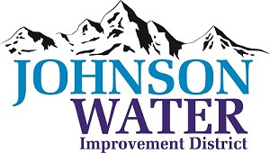
3748 West Highway 87
Roosevelt, UT 84066
Phone (435) 722-2620

January 31, 2024

SUBJECT: Board Meeting

The Regular Board Meeting is Thursday, February 8th at 6:30 p.m.

Agenda:
- Appointments:
  - Jason Blankenagel, Sunrise Engineering ~ Updates on Construction projects

- Minutes ~ December 2023
- Financial ~ December 2023

- Election:
  - Response letter to County Commissioners on the Election

- Manager Report:
  - Duchesne City & Myton City Contracts
  - Who is going to the Rural Water Conference?
  - CIB report on the meeting on February 1st.

- Personnel Policy discussion

- Swear in New Board Members

- Reorganize: Chairman, Vice Chairman, Treasurer etc.
  - Board Meeting Dates & Time schedule for 2024
  - Holidays for 2024

- Old Business

- Closed Session: Purpose listed in the Utah Code 52-4-205 (1) (d)

