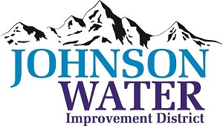
3748 West Highway 87
Roosevelt, UT 84066
Phone (435) 722-2620

October 7, 2023

TO: Board Members

SUBJECT: Board Meeting

Please be reminded that the Regular Board Meeting is Thursday, October 12th at 6:30 p.m.

Agenda:

- Appointments:
  - CKC ~ Justin Robb fire hydrants
- Water connection discussion
  - Jason Blankenagel, Sunrise Engineering ~ Updates on Construction projects

- Minutes ~ August and September
- Financial ~ September

- Resolution in cancellation of election for 2023

- Policy & Ordinance and hiring 3rd party discussion.

- Manager Report:
  - Policies
  - XCL projects on what they are planning to do.
  - HR Consultant discussion.

- Closed Session: Purpose listed in the Utah Code 52-4-205 (1) (d)

