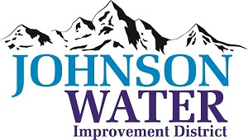
3748 West Highway 87
Roosevelt, UT 84066
Phone (435) 722-2620

April 12, 2024

SUBJECT: Board Meeting

The Regular Board Meeting is Thursday, April 18th at 6:30 p.m.

Agenda:
- Appointments:
  - Jason Blankenagel, Sunrise Engineering ~ Updates on Construction projects

- Minutes ~ March2024
- Financial ~ March 2024

- Manager Report:
  - Independence Connector Project
  - PRV rehabilitation project
  - Insurance: Open enrollment closes ~ May 17th

- Personnel Policy

- Fraud Risk Assessment
  - Conflict of Interest
  - Code of Ethical Conduct

- Duchesne City Contract counteroffer

- Meter Connection Policy discussion

- Old Business

- Closed Session: Purpose listed in the Utah Code 52-4-205 (1) (d)

