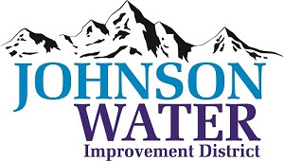
3748 West Highway 87
Roosevelt, UT 84066
Phone (435) 722-2620

January 12, 2024

SUBJECT: Board Meeting

Regular Board Meeting is Thursday, January 18 at 6:30 p.m.

Agenda:

- Appointments:
  - Jason Blankenagel, Sunrise Engineering ~ Updates on Construction projects

- Minutes ~ December
- Financial ~ December

- Manager Report:
  - Election update
  - Policies
  - Funding for a Scada System
  - Who is going to Rural Water February 26 to March 1
  - Personnel Policy – Employee Handbook update
  - CIB meeting update and results
  - Duchesne City Contract

- Old Business

- Closed Session: Purpose listed in the Utah Code 52-4-205 (1) (d)

