Johnson Water Improvement District
2019
Water Conservation Plan
System Profile

Johnson Water Improvement District (JWID) provides culinary water to the residents of Eastern Duchesne County and Western Uintah County. Founded in 1969 as Myton Water Association its name was changed to Johnson Water Association and in 1983 it became Johnson Water Improvement District (JWID).
JWID provides much needed culinary water for the residents, farms, ranches, businesses, and industry located within the boundaries of the district. JWID also shares and maintains the waterline and tank that provides all the culinary water to the city of Myton, Utah.
JWID also provides water to parts of Roosevelt City, Utah and was instrumental in providing the water to develop the airport and industrial area of Roosevelt as well as some of their residential areas.
JWID has many miles of pipeline and a relative few customers. The economics of this is sustained by our very large industrial customers who use large amounts of water in oil field production and hydraulic fracturing.
JWID is constantly trying to improve the delivery and quality of water delivered to our customers for drinking, farming, ranching, industrial, and fire flow requirements.
Most of the water comes from the Duchesne Valley Treatment Plant north of Duchesne, Utah. JWID also has two wells that are used for industrial use only, mainly fracking.
The treatment plant is dealing with the aftermath of the Dollar Ridge Fire in the summer of 2018 that has caused the level of organics and turbidity in the Starvation Reservoir to skyrocket. Major modifications to the plant are now being started to deal with the changes to the reservoir. Due to the increase in organics from the lake more chlorine will be needed to the system and more flushing will be needed to get a chlorine residual to the end of the line.

Map of JWID

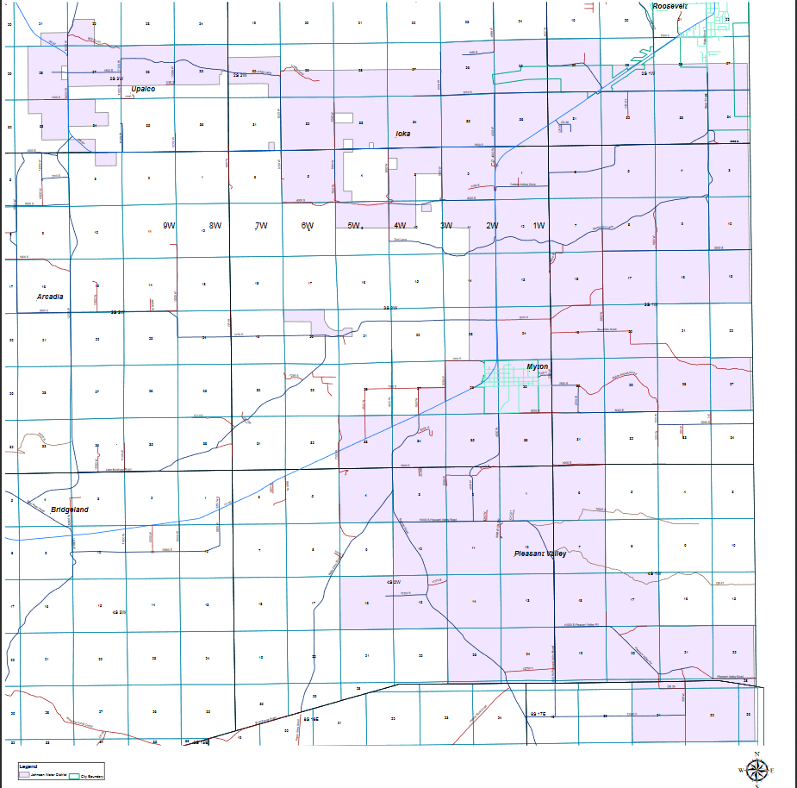

Categorized connections

Residential connections 726
Commercial connections 94
Institutional connections 0
Industrial connections 17
Total connections 837

Supply

Source | Total AF
Wells | 153
Purchased | 2287
Total | 2440

JWID gets most of its water from Duchesne City and from The Duchesne County Water Conservancy District. Both sources use water rights owned by Duchesne City out of the Starvation Reservoir. The water is treated at the Duchesne Valley Treatment Plant run by the Central Utah Water Conservancy District.
JWID also has two groundwater wells used for culinary water until 2016 and now used for industrial water only.
JWID purchases culinary water from several sources, they are:
- Duchesne City
- Duchesne County Water Conservancy District
- Upper Country Water Improvement District
- Ute Tribe
- East Duchesne Water Improvement District

Comparison Graph Reliable Supply
There are too many variables to predict accurately what future use and efficient use will look like in the future. Some of the factors to consider are:
1. Oil Price fluctuation has a big impact on the amount of water needed and used. As the price of oil increases the water use also increases.
2. Expanding oil transportation options could have a very large impact on oil production in the Uintah Basin. Currently the only economical market for the oil is in the Salt Lake area oil refineries. At the present time the refineries can only process 80,000 barrels of oil a day from the basin and that point has been reached. In order to produce more oil, other markets will have to be opened by using new Railroad connections, Pipelines, or by refining more product before it is transported. These options are all being explored at the present time. The Seven County Infrastructure Coalition is working on the railroad funding and routing.
3. One Fracked horizontal well produces as much as 30 traditional wells. Fewer wells will be drilled and fewer employees will be needed to drill and maintain them. That means less demand for residential/domestic housing and water.
4. Oil companies securing other sources or supply of Frac water creates uncertainty in future use of culinary for those fracking operations. Oil companies are aggressively seeking less expensive and larger supplies of water. They are trying to lease irrigation water from irrigation companies and shareholders. They are also trying to buy or lease water from the Ute Tribe.
5. New fracking technology that utilizes less water is also on the horizon. The recipe for fracking a well is constantly changing.

Future Water Sources and Cost Projections

JWID in conjunction with other water users of the Duchesne Valley Treatment plant have been discussing with officials of the Central Utah Water Conservancy District anticipated water needs from the treatment plant.
All the users have been experiencing increased industrial use mainly from hydraulic fracturing processes used in the oil industry. These uses are year-round but are intermittent. Each water supplier serves one or more oil companies and their schedules change daily. This creates problems because of the fluctuation in the amount that needs to be produced from day to day and requires that the treatment plant get advance notice of changes in daily flows.
Currently plans are being made for treatment plant modifications to deal with the effects of the Dollar Ridge Fire and the spring and fall algae events which lower plant production. The costs for these modifications will be between 18-25 million dollars.

Measurement methods
All JWID water is metered at the source and at the point of connection to the end user. All JWID water use is metered except breaks and flushing. JWID has a constant program of calibration and replacement of water meters.

System Water Loss Control
System Water Loss Control- We Immediately repair all known leaks. We have a maintenance program to maintain fire hydrants, valves, air vents, PRVs, and meters.
We average about 12 connections per mile and 13,779 gallons per mile in an 8” pipe in the eastern part of our district. Because of the low number of connections, the water tends to become stagnant and loose chlorine residual because of low flow rates.
JWID has the responsibility to maintain the quality of water in the system which requires that the supply lines be flushed from time to time to maintain a chlorine residual. The flushed water is wasted and goes into drainage ditches and downstream. In some areas of the system where fracking is occurring or where there is enough use of the water there is no need to flush the water lines. In the opinion of JWID it is better for the customer to waste water and pay for it, than to flush it on the ground with no compensation.

Tiered pricing structures:
We are currently looking at implementing a tiered pricing structure. Because of the problems we deal with regarding water quality and chlorine residual in our water system, we have found it to our advantage to move as much water as possible through our water lines, especially at the eastern end of the system. We are hesitant to reduce the flow in this area if we implement a tiered pricing structure at this time because of the adverse effects it would have on water quality.
Our water rate structure is shown below.
Residential
Base rate of $35.00 up to 6000 gal for ¾ “connection then $1.57/1000
Base rate of $46.00 up to 8,000 gal for 1” connection then $1.57/1000
Commercial
Base rate of $35.00 up to 6000 gal for ¾ “connection then $2.52/ 1000
Base rate of $66.00 up to 10,000 gal for 1 “connection then $2.52/ 1000
Industrial
Contracted Frac Water #1 $3.19/1000 gal.
Un-contracted Frac water #2 $4.76/ 1000/gal.

Water Use

Annual Use Information in Acre Feet

Year Domestic Commercial Industrial Institutnl Stock Wholesale Other Unmetered Total
2018 428.11 41.23 1628.44 2097.78
2017 444.26 62.54 1191.41 0.00 0.00 0.00 0.00 0.00 1698.21
2016 449.85 59.80 866.15 0.01 0.00 0.00 0.00 0.00 1375.81
2015 630.11 58.17 1054.73 0.07 0.00 0.00 0.00 0.00 1743.08
2014 356.14 48.82 1348.74 0.00 86.58 0.00 0.00 0.00 1840.28
2013 451.61 37.94 1191.99 0.17 71.46 0.00 0.00 0.00 1753.17
2012 434.18 33.46 887.46 0.14 73.34 0.00 0.00 0.00 1428.58
2011 389.48 48.41 883.14 62.60 44.95 0.00 0.00 0.00 1428.58
2010 598.34 18.80 734.32 0.15 44.17 0.00 0.00 0.00 1395.78
2009 477.38 12.74 704.02 0.16 68.62 0.00 0.00 0.00 1262.92
2008 460.69 36.04 864.32 1.25 54.13 0.00 0.00 0.00 1416.43
2007 403.91 2.66 963.21 1.25 123.01 0.00 0.00 0.00 1494.04
2006 281.66 12.22 1279.68 0.70 100.40 0.00 0.00 0.00 1674.66
2005 527.02 8.16 744.96 0.16 74.17 0.00 0.00 0.00 1354.47

Potable water
Residential/domestic 139,503,000
Commercial 13,436,000
Institutional 0
Industrial 530,630,000
Total 683,569,000.00

Chart of Per Capita water use in gallons per capita per day (GPCD)
Many of JWID residential connections are also used for the watering of livestock, some have several hundred head of livestock. A great number do not use culinary water for outdoor watering because they own water shares in an irrigation company and that water is used for lawns and gardens. Because of these situations there is not as great a difference between winter and summer usage as there would be in suburban areas.

Total water deliveries/365/total service area population =GPCD
 | GPCD
Residential | 180
Commercial | 17
Institutional | 0
Industrial | 686
Total | 883

Water efficiency progress
JWID water efficiency progress is determined largely by industrial use. As the oil companies bring on new wells that exceed the ability of the Salt Lake Refineries to process, drilling will slow down, and fracking will also slow down and demand for industrial water will decrease. World oil prices will also dictate the amount of oil production, and therefor water use, that will take place.

Conservation Practices
The manager is assigned to monitor conservation efforts.
JWID meters all water.
JWID repairs leaks promptly.
JWID follows Utah laws relating to operation of service districts.

Contact Information

Conservation Advisory committee Dickson Taylor 435-724-2620
Conservation Staff Dickson Taylor 435-724-2620

Emergency Plan

Our emergency plan in case of drought, natural disaster, or supply disruption puts priority on residential domestic use above all other uses. JWID industrial users have been made aware they are in last place in priority in emergency situations. In drought situations they will be shut off completely in order to provide water to residences.
Conservation
JWID includes in the Consumer Confidence Report (CCR) a few conservation tips and links to www.epa.gov/waterwise . From time to time JWID includes tips on the bill that is sent out monthly. JWID is installing new meters and radios that track hourly water use for the last 90 days to help identify leaks and water use the customer may not be aware of.

New Best Management Practices
- Adhere to laws pertaining to municipalities and water improvement districts so that water service areas do not overlap.
- Determine how to maintain a chlorine residual at the ends of our system without over flushing or increasing disinfection by-products in our distribution system.
- Inform customers of methods to include landscaping that is beautiful and still requires less irrigation such as using native plants bushes and trees.
- Encourage industrial users to research latest water efficient methods of oil and gas extraction.

Public awareness practices
Johnson Water Improvement District is taking steps to make our customers more aware of the need to conserve water.
We are currently building a website to help educate the customers in conservation practices and to show more information about the efficient use of water.

Conclusion
Johnson Water Improvement District is unique from many other water districts or cities. It depends on industrial water use to help pay for the long distances between customers. It covers a large area with many changes in elevation that present a challenge in delivering water to the area.
Because of the large influence of the oil industry it is hard to predict future water use accurately.
Because of the Dollar Ridge Fire, it is hard to maintain a chlorine residual to the ends of the system even with substantial flushing which wastes a lot of water.
Adding chlorine boosters is an option but also increases the presence of disinfection by products which must be watched carefully.
Johnson Water Improvement District will take all steps possible to conserve water now and into the future and still provide quality water to its customers.

