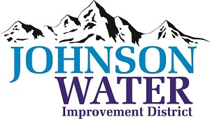

3748 West Highway 87

Roosevelt, UT 84066

Phone (435) 722-2620

June 12, 2025

SUBJECT: Regular Board Meeting

**The Board Meeting** is Thursday, June 19th @6:00 p.m.

**Agenda**:

1. We will have Board Training @ 6:00
2. Public Hearing @6:30 ~ Water Conservation Plan
3. Audit ~ Cameron Olson, Aycock, Miles & Associates CPA’s
4. Minutes ~ May 2025
5. Financial ~ May 2025
6. Appointments:
   1. Sunrise Engineering ~ Updates on Construction projects
   2. Jones & DeMille ~ Master Plan update
7. Manager Report:
   1. Leak Policy
   2. Update: Emergency Response Plan
   3. System Updates
   4. CCR Report
8. Elections Update
9. Old Business:
10. Closed Session: Purpose listed in the Utah Code 52-4-205 (1) (d)